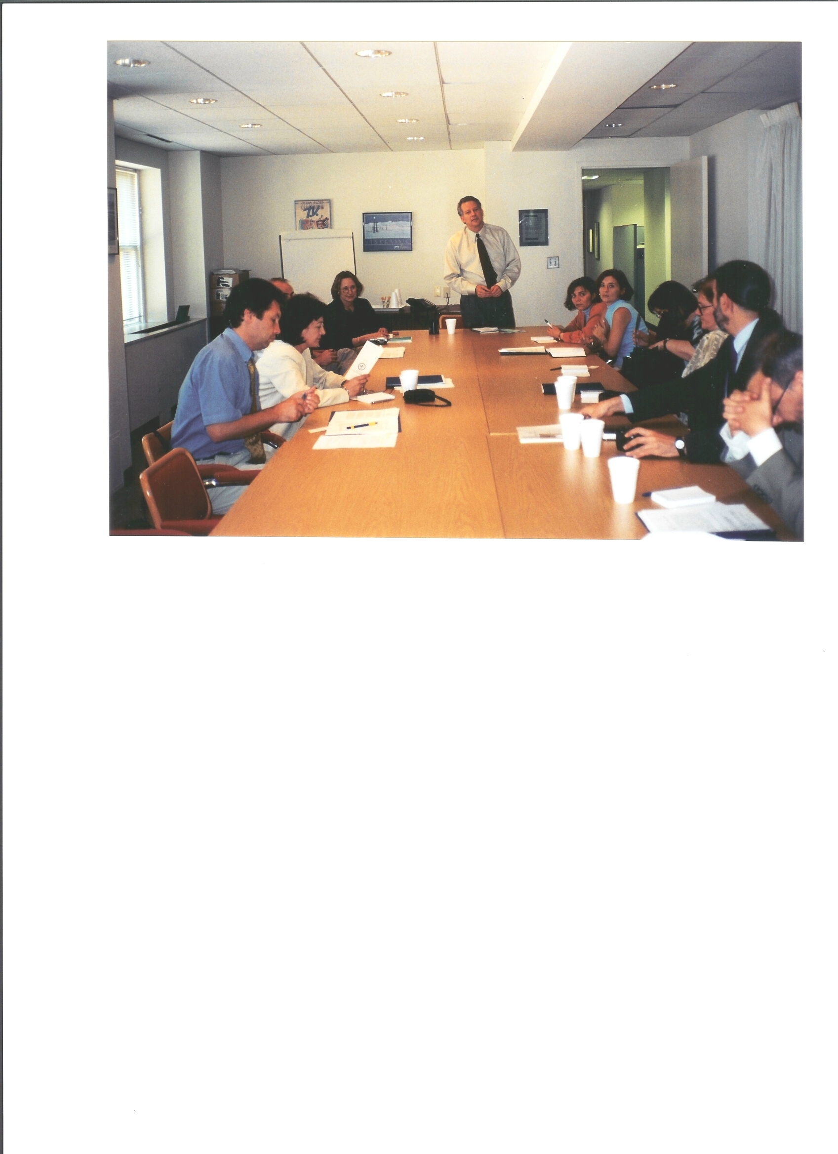
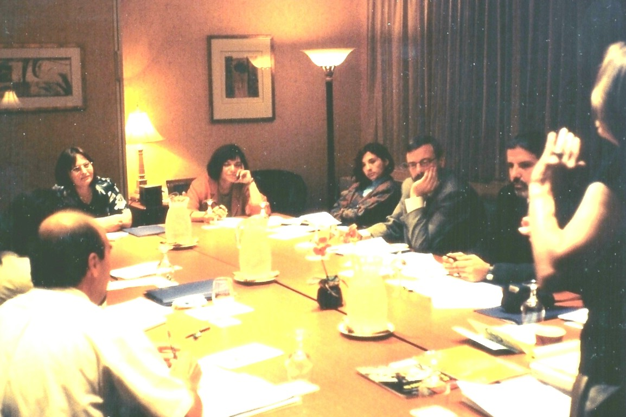
Mr. John M. Lewson, President/CEO of the Association of America’s Public Television Station (AAPTS) shown directing the USAID/IMMA Ltd session with the Bulgaria Media Coalition and National Association of Broadcasters. Shown to the left of Mr. Lewson is Program Chairman Ms. Caroline Brownstone, President/CEO of IMMA Ltd.
In alpha order are further participants attending the Bulgaria Media Associations meetings, including IMMA Ltd Program Manager Ms. Caroline Brownstone and Senior Trainer Mr. Gregg Brown: Ms. Antonaneta Stoyanova Arsova, Exec. Director, Association of Bulgarian Broadcasters (ABBRO); Mr. Yassen Invanov Boyadzhiev, Chairman of the Board of Directors of the Bulgarian Media Coalition (BMC); Mr. Krasimir Stoyanov Dimitrov, Regional Coordinator, Association of Bulgarian Broadcaster; Ms. Gergana Delova Jouleva, Chairperson of the Bulgarian Media Coalition’s Access to Information Program Foundation; Ms. Assya Raicheve Kavrakova, Chairperson of the Bulgarian Media Coalition’s Media Legal Support Group (which developed a functional legal framework for the independent media in Bulgaria); Ms. Mariya Stefanova Neykova, Executive Director of the Bulgarian Media Coalition; Ms. Rossitza Ljubenova Panova, Association of Bulgarian Broadcasters’ Program Coordinator; and Mr. Dimitar Sotirov, Executive Director, Bulgarian Media Coalition

